Manual Test Plan for GUI

1. Upon opening the app you should see an empty list and an add button (Figure 1)
2. Upon clicking the add button, the user should be able to create a new study session (Figure 2)
3. The user can change time for the study session and set a recurrence/end date (Figure 3, 4, 5)
4. After clicking the “check” button on the action bar, the main activity with the newly added study session is shown (Figure 6)

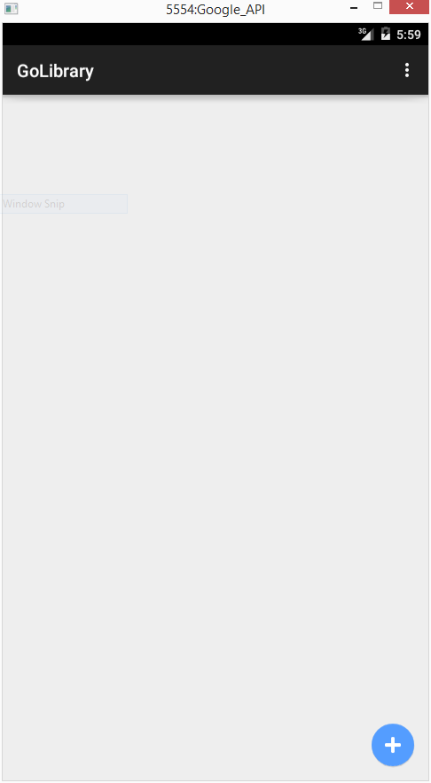

Figure

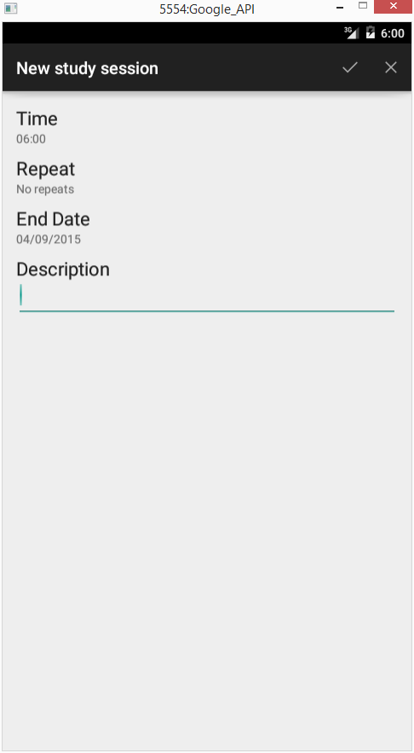

Figure

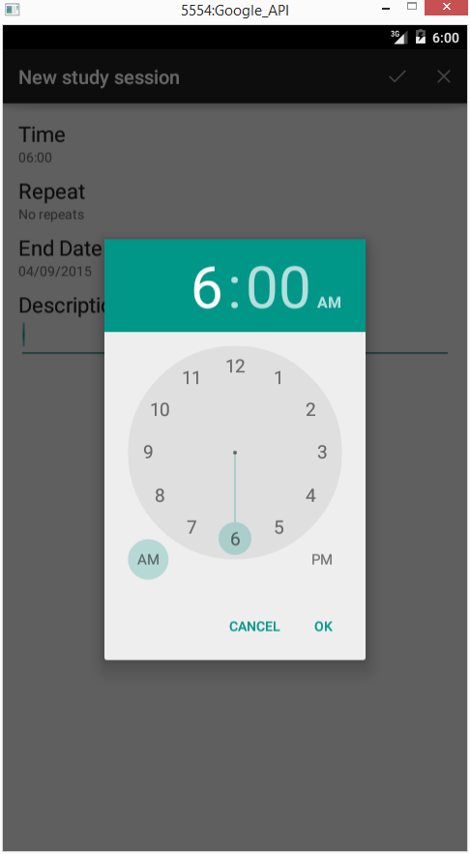

Figure

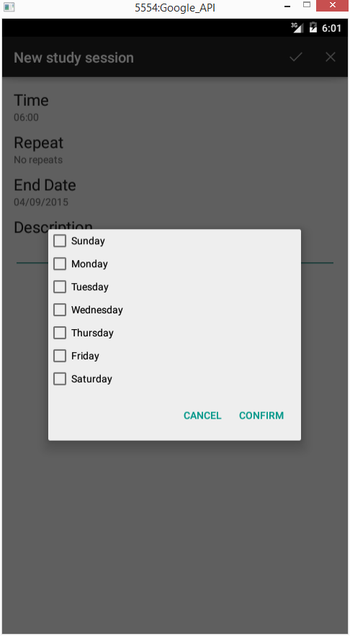

Figure

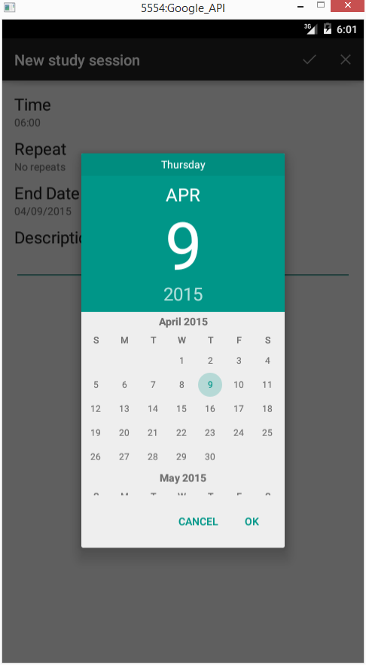

Figure

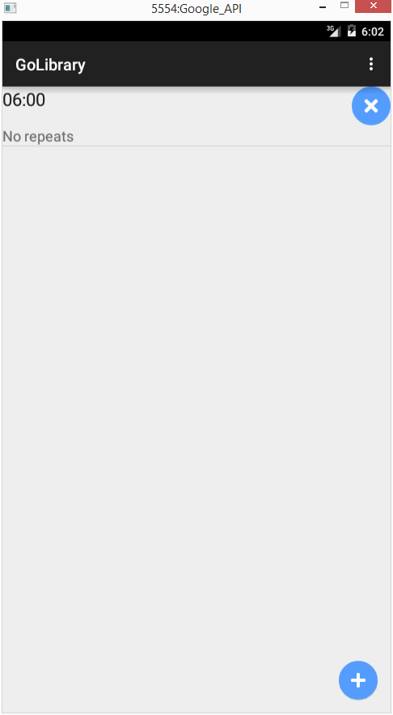

Figure

Testing Location Service

Step1. Setup a study session 1 minute after.

Step2. After one minute, a notification should pop out. If you are near Siebel center or Grainger the notification should say you will not be punished. Otherwise, it will say I will punish you and a punishment message is posted to your facebook.

Testing Facebook Login

If the user is not logged into Facebook. The app will open the Facebook login

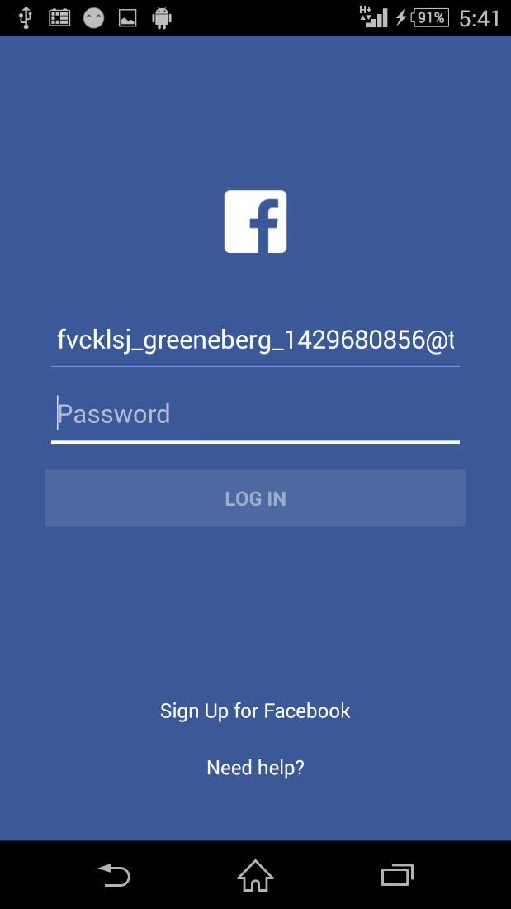

The first time the user use the app, the app will ask for permission to access the user’s public profile and the posting to the timeline

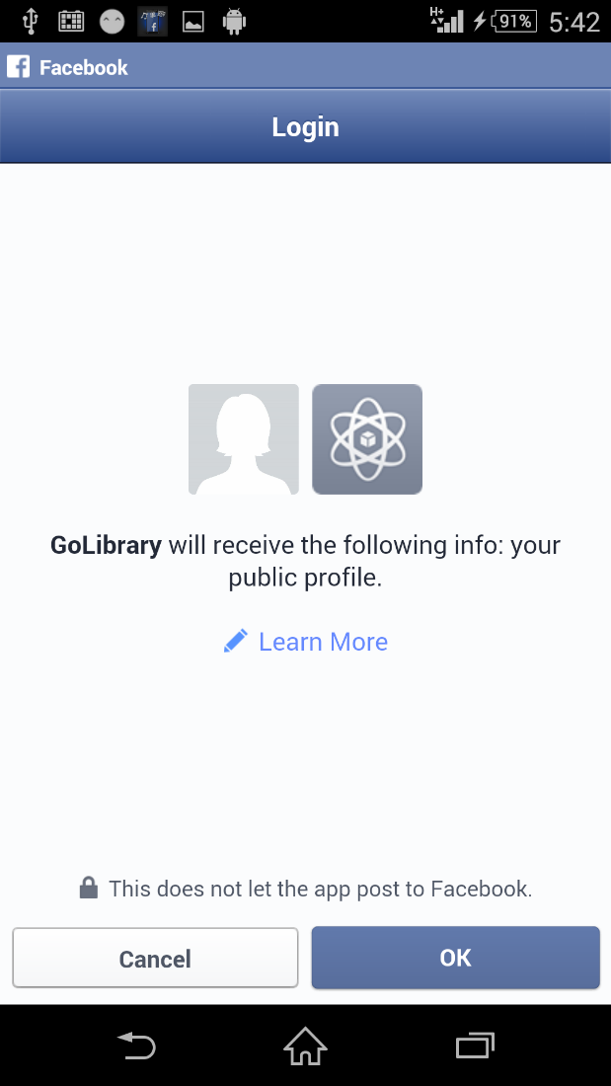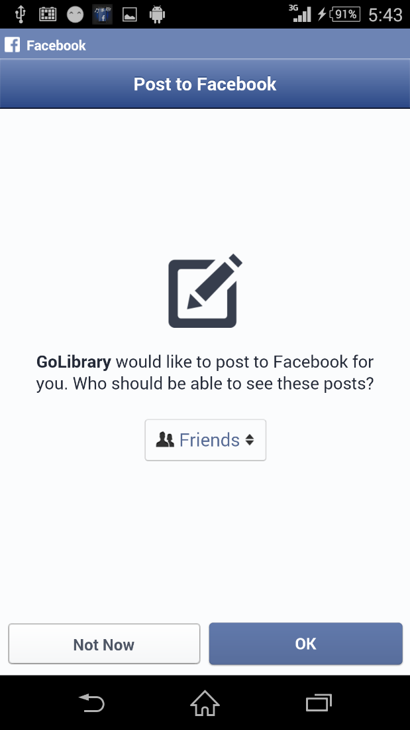

If the login failed (e.g. no internet connection) The app should show the following dialog and quit peacefully upon clicking OK

